John (Jack) McCarthy, Jay Bang, Julia Cutright, Brendan Tran

CSC – 481

Professor Nelson

12/9/2020

Final Report: Specification, Design, and Schedule

**Specification**:

Our project is an attempt to create a program that can assist the advisors here at Saint Martin’s University. These advisors are responsible for planning an academic path for each student as they go about there time here at the university. We personally know multiple students who now need to take extra semesters in order to complete their degree because of advisor error or lack of foresight of coming situations. Because of this, we plan to create this program to fix this problem and ease the process of advising to help the advisors and students alike. To reach this goal we are creating a system that has the input specified below that will go into a web-application based validation process that ideally will check for potential error or issues with the path that is produced by the advisor.

**Design**:

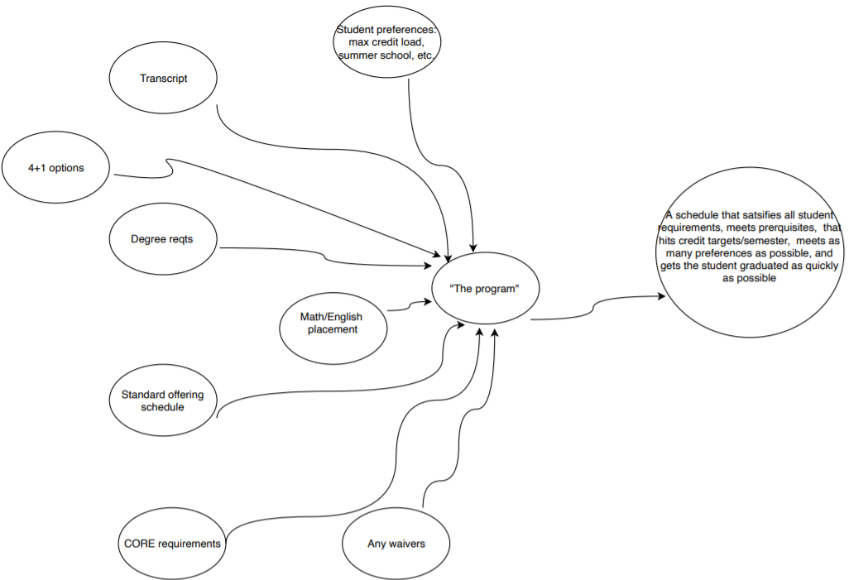The design of this system is fairly simplistic. With the data secured from the input slots, back-end functions will then load and compare the presented course path looking for error along the lines of things such as prerequisites and when specific course are offered (Fall or Spring). When selecting courses before submitting for validation, ideally the page will be able to query into the course database that is utilized by Self-Service currently and read in the attribute of the course being searched for. These will then be loaded into the back-end of the system and saved for later validation. The output of this system will ideally be a savable file that the student can refer to when planning their courses.

**Schedule**:

As it currently stands, we have a tentative schedule that goes as the following: by February 16th we plan to have the basics of the system complete and able to create an output file that is usable by the student it is intended for. Following this, by March 16th there should be a standard created for each major, this would be created to be used as a reference when planning. Finally, by April 16th we will have implemented the reading in of transcripts for students that have already completed courses here at Saint Martin’s and other places.